**C:\Users\25261\AppData\Local\Microsoft\Windows\Temporary Internet Files\Content.IE5\DHDN2MK8\MC900391148[1].wmfLine Spacing**

**Target:** I can change the line spacing in Microsoft Word

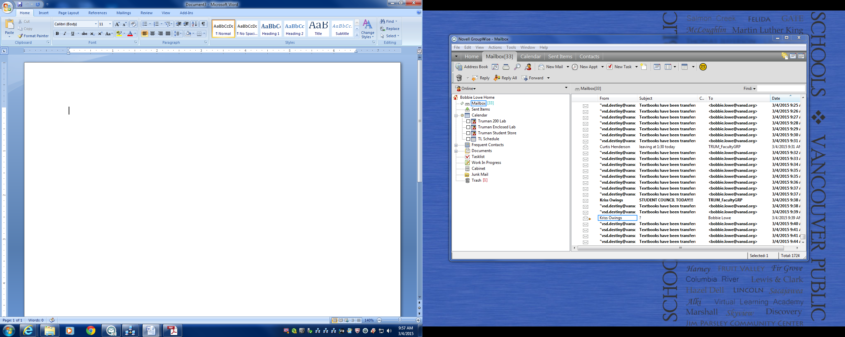

1. Highlight this sentence and type your name.

2. Line spacing is the amount of space between the lines. The smaller the number the less space. Highlight this paragraph and change the spacing to 2.5.

3. Change the line spacing of this list to 1.0

* Apple
* Orange
* Banana
* Peach
* Grape

4. Change the line spacing of this list to 1.5

* Red
* Orange
* Yellow
* Green
* Blue
* Purple