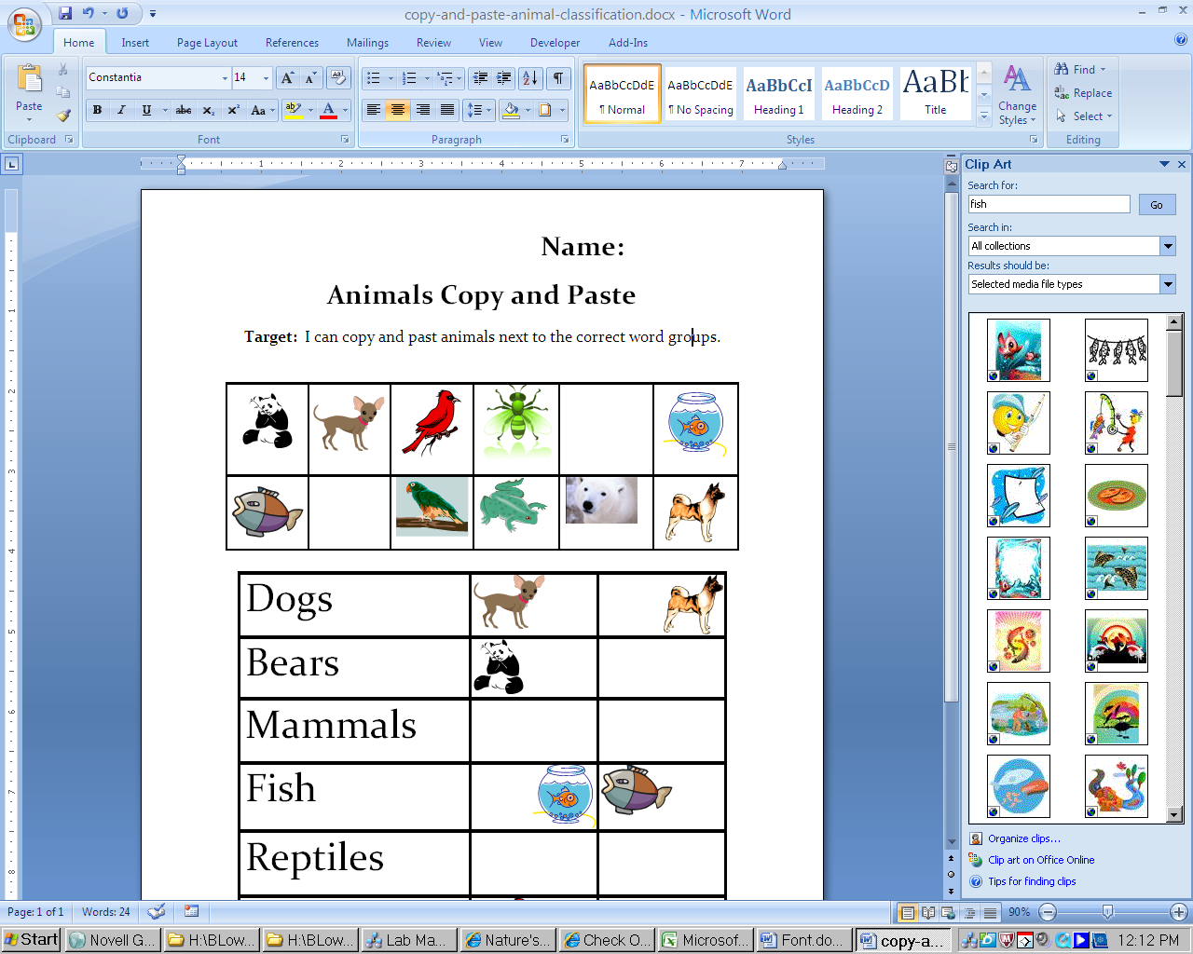**Name:**

**C:\Users\25261\AppData\Local\Microsoft\Windows\Temporary Internet Files\Content.IE5\DHDN2MK8\MC900391148[1].wmfAnimals Copy and Paste**

**Target:** I can copy and past animals next to the correct word groups

|  |  |  |  |  |  |
| --- | --- | --- | --- | --- | --- |
| C:\Documents and Settings\25261\Local Settings\Temporary Internet Files\Content.IE5\JOI3HW4U\MC900021323[1].wmf | C:\Documents and Settings\25261\Local Settings\Temporary Internet Files\Content.IE5\K1QV8A5S\MC900435448[1].wmf | C:\Users\administrator\AppData\Local\Microsoft\Windows\Temporary Internet Files\Content.IE5\1IDY3W9X\MC900151177[1].wmf | C:\Documents and Settings\25261\Local Settings\Temporary Internet Files\Content.IE5\VHWJHBC9\MC900088446[1].wmf | C:\Documents and Settings\25261\Local Settings\Temporary Internet Files\Content.IE5\I60GW52B\MC900335870[1].wmf | C:\Documents and Settings\25261\Local Settings\Temporary Internet Files\Content.IE5\RMRZ06IF\MC900391432[1].wmf |
| C:\Documents and Settings\25261\Local Settings\Temporary Internet Files\Content.IE5\JOI3HW4U\MC900417528[1].wmf | C:\Documents and Settings\25261\Local Settings\Temporary Internet Files\Content.IE5\RMRZ06IF\MC900034141[1].wmf | C:\Documents and Settings\25261\Local Settings\Temporary Internet Files\Content.IE5\JOI3HW4U\MC900391474[1].wmf | C:\Documents and Settings\25261\Local Settings\Temporary Internet Files\Content.IE5\KM03NVEW\MC900436209[1].png | C:\Documents and Settings\25261\Local Settings\Temporary Internet Files\Content.IE5\VHWJHBC9\MC900053159[1].wmf | C:\Documents and Settings\25261\Local Settings\Temporary Internet Files\Content.IE5\XR6KVOHY\MC900001551[1].wmf |

|  |  |  |
| --- | --- | --- |
| Dogs |  |  |
| Bears |  |  |
| Cat |  |  |
| Fish |  |  |
| Bug |  |  |
| Birds |  |  |

**Fist to Five Check In:** Please circle one